Air Quality Sensor Data Analysis
COMP5048 Assignment 2

Kavvin Udhayakumar Valarmathi
Student ID number
Yan
Student ID number
Caroline Li
Student ID number
Xueqi Bao
Student ID number
Group: 5048-CC-03-G06
Tutor: Wilma

Task 1

Data and Preprocessing
We used the UCI Air Quality dataset [1]: hourly averaged responses of a metal-oxide multisensor device at road level in an Italian city, with reference analyser values and weather readings [2]. It has 9,357 hourly records from 10 March 2004 18:00 to 4 April 2005 14:00, with no duplicate or missing timestamps, and 13 value columns. Missing values are coded as −200.
Before cleaning, we checked the raw file ourselves and found that:
- −200 is the only missing code. CO(GT) is 18.0% missing, NOx(GT) and NO2(GT) 17.5%, NMHC(GT) 90.2% (valid only until 1 May 2004) and every other column 3.9%.
- Missing values are not random: the sensor columns, C6H6, T, RH and AH go missing together (366 hours), 31 hours have no data at all, and NOx and NO2 are missing at 03:00 on 93% of days and CO at 04:00 on 54%.
- C6H6(GT) is almost a perfect function of PT08.S2(NMHC) (Spearman 0.99998): the same S2 value always gives the same C6H6 value within 0.1.
- AH matches the water vapour pressure (kPa) calculated from T and RH, so it is a derived column. NOx(GT) is in ppb, while NO2(GT) is in µg/m³.
- The sensors drift [2]: at a fixed NOx level, the PT08.S3 response ranges from about 620 to 923 by month, and PT08.S4 follows T and AH (r = 0.56 and 0.63) more than NO2 (r = 0.16).
Our cleaning script reads the CSV (semicolon separator, decimal comma), drops 114 blank rows and two empty columns, builds an hourly timestamp and replaces −200 with NaN; nothing is imputed. It then checks that no rows were lost, no −200 remains, each column has as many NaNs as the raw file had −200 values, and all other values are unchanged.

Attribute Selection
We selected the timestamp, CO(GT), C6H6(GT), NOx(GT), NO2(GT), PT08.S1(CO), PT08.S5(O3), T and RH (nine attributes) and used them in every task, covering true concentrations, sensor responses and the environment. We left out NMHC(GT) (mostly missing), AH (derived from T and RH), PT08.S2 (duplicates C6H6), and PT08.S3 and PT08.S4 (strongest drift and temperature effects). Views that show all attributes need complete hours: 6,941 hours (74%), with October 2004 the weakest month at 50%.
Some attributes overlap: C6H6 and CO are strongly related (r = 0.93), and S1 and S5 both follow CO (r = 0.88 and 0.85). A group defined by high CO, C6H6, S1 and S5 is therefore one traffic signal seen several times, not four separate factors.

Visual Analytic Tool
We built our own web application with four linked views, all using the same 6,941 complete hours, with hour of day, weekday, month and season derived from the timestamp.
- Parallel coordinates [3] is the main view. Each hour is one line, so similar hours form bundles, and the axes a bundle passes through show which attributes define it. Lines can be coloured by season, time of day (four 6-hour bands), weekday/weekend or saved group.
- A scatterplot of any two attributes shows separation and density for a pair.
- A daily heatmap (one row per day) shows each attribute’s daily median by colour lightness and cell width, so groups of days stand out.
- A group panel shows, for each hour of day, weekday and month, the share of hours in that slot that belong to a group, together with the group medians.
The axes go analysers, sensors, then T and RH, so related pollutants sit next to each other, and they can be dragged to reorder. Each axis spans the 1st to 99th percentile with its raw end values labelled, because with the full range a few extreme hours pushed most lines to the bottom; the ranges stay fixed when filtering, so views can be compared. With almost 7,000 lines we used low opacity and a fixed random drawing order so that no season is always on top, and clicking a legend entry shows only that category. Only three colours passed our colour-blind check for every pair, so the tool allows three saved groups.
Following “overview first, zoom and filter, then details-on-demand” [4], the user starts from all hours, filters by date, season, month, day type and hour, and selects hours by brushing one or more axes, dragging a box in the scatterplot or clicking heatmap days. The selection is highlighted in all views and can be saved as a group with its own colour and median line. No clustering algorithm was used; groups were found only by looking and brushing.

Discovery of Groupings
We first coloured the parallel coordinates by season and showed one season at a time (Fig. 1). Winter lines sit at the bottom of T and the top of RH, many reaching high on NO2; summer lines meet at the top of T and the bottom of RH and drop to the floor of the NOx axis; autumn held most lines running along the top of every pollutant and sensor axis. Colouring by time of day showed night lines (00–05) along the bottom of the pollutant axes and afternoon lines (12–17) in the hot, dry bundle.
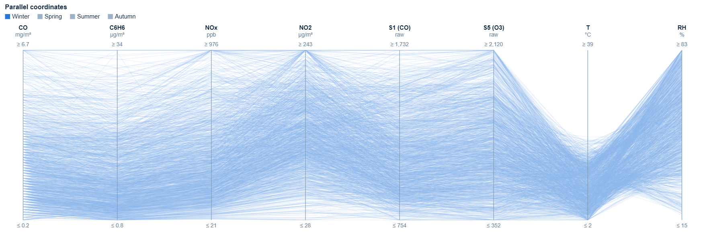
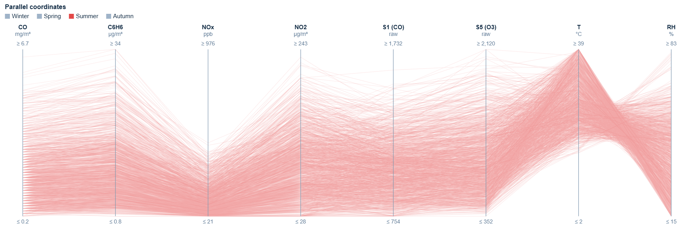
- Parallel coordinates showing only winter (top) and only summer (bottom).
We then brushed each bundle where it sits on the axes:
- Group A: the upper half of the CO axis (CO ≥ 3.5 mg/m³), where lines also stay high on the other pollutant and sensor axes;
- Group B: the bottom band of CO and NOx (CO ≤ 0.9 mg/m³ and NOx ≤ 90 ppb), where the night lines are;
- Group C: the top third of T and the bottom of RH (T ≥ 26 °C and RH ≤ 35%);
- Group D: the lower part of T (T ≤ 10 °C).
A, B and C were saved as groups (Fig. 2) and D was kept as the current selection, since the tool allows three saved groups. Table I summarises them using the group panel (Fig. 3), whose bars give the share of hours in each slot; for example, 36% at 08:00 means that 108 of the 303 complete hours at 08:00 belong to Group A.
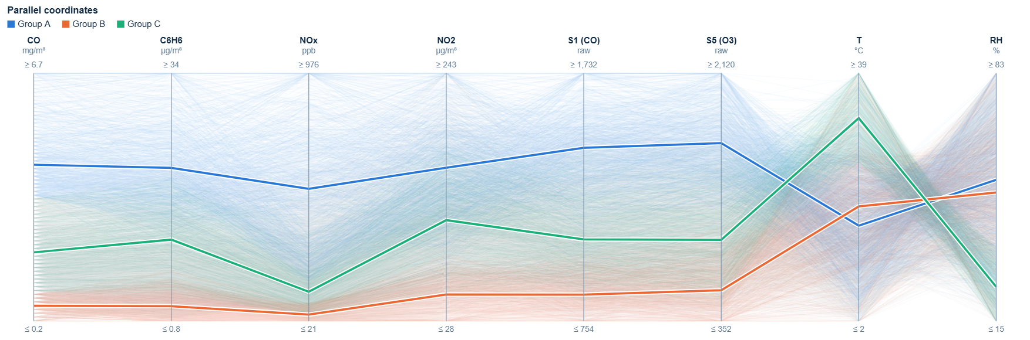
- Parallel coordinates coloured by saved group. Thick lines are the group medians.
- Groups Found in the Parallel Coordinates
Group | Brush | Hours | Defining attributes | Time periods
A: traffic peaks | CO ≥ 3.5 | 1,172 (17%) | High on all pollutant and sensor axes. Medians CO 4.3, C6H6 22, NOx 531, NO2 161 (all hours: 1.9, 8.8, 186, 110). T and RH typical | 08–09 (36–37%) and 18–20 (44–51%). Tue–Fri 22–24%, Mon 14%, Sat 9%, Sun 4%. Almost none in Aug 2004 (1 hour); highest Oct–Nov 2004 (29–31%)
B: clean nights | CO ≤ 0.9, NOx ≤ 90 | 855 (12%) | Floor of all pollutant and sensor axes. Medians CO 0.6, C6H6 2.8, NOx 46, NO2 51 | 02–06 (64% at 04–05). Sun 24% vs 8–14% on other days. Mostly Apr–Aug 2004 (16–29%); rare Oct 2004–Mar 2005 (4–7%)
C: hot, dry afternoons | T ≥ 26, RH ≤ 35 | 906 (13%) | High T (median 33 °C), low RH (24%) and low NOx (134); CO and NO2 typical | 10:00–20:00 (28–32% at 12–17). All days 11–16%. May–Sep 2004, peak Jul 2004 (53%); none Oct 2004–Feb 2005
D: cold, humid hours | T ≤ 10 | 1,431 (21%) | Low T (6.6 °C), higher RH (57%), high NOx (254) and NO2 (131) but CO below typical (1.6) | Mostly 00–09 (25–34%, except 03:00) vs 9–11% at 12–17. All days similar. Mainly Nov 2004–Mar 2005, peak Feb 2005 (78%)

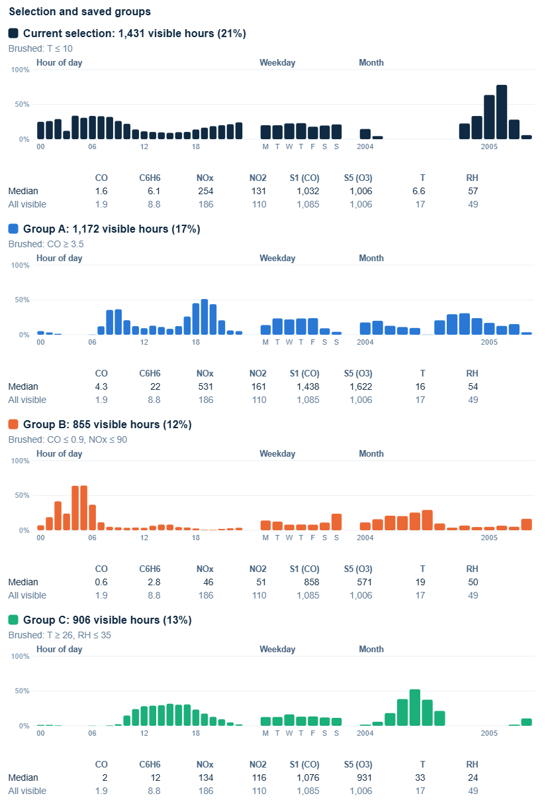
- Group panel: share of hours in each hour of day, weekday and month that belong to each group, with medians. The top card is the cold-hours selection (Group D).

Groupings over Hours and Days
The groups depend on the hour and the day, and the same hour can belong to different groups: afternoons are often in Group C in summer but never in winter, and early mornings are often in Group B in spring and summer but rarely in winter (Fig. 3). The daily heatmap also shows groups of days (Fig. 5): in November 2004 the Sundays (7, 14 and 21 November) are lighter on every pollutant column with almost no Group A hours, while 22–27 November forms a dark block that looks like a pollution episode lasting several days.
In the scatterplot (Fig. 4), Groups A and B sit at opposite ends of the CO–C6H6 band, while Group C sits on its upper edge, so hot hours have more C6H6 for the same CO, which we think is at least partly an effect of the temperature-sensitive sensor behind C6H6.
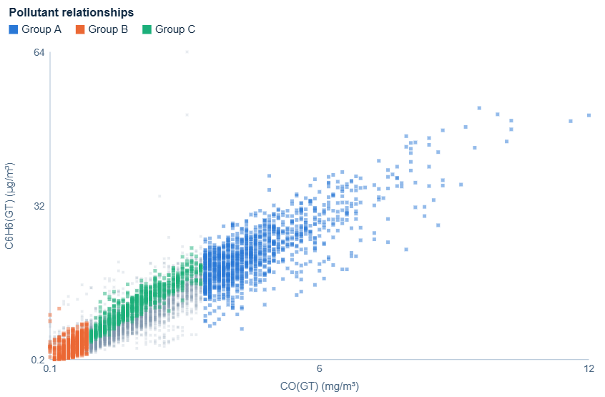
- CO against C6H6, coloured by group.
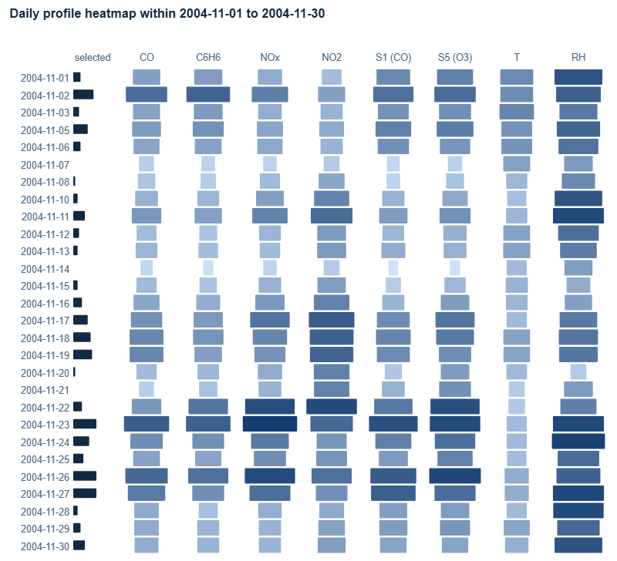
- Daily heatmap for November 2004 with the CO ≥ 3.5 brush active. The left bar counts high-CO hours per day.

Robustness of the Brushes
The brush positions are visual choices, not exact boundaries, because the data is continuous. We moved each brush in both directions (Table II): the group sizes and percentages change, but the patterns stay the same. A always has the morning and evening peaks and almost no hours at night, on Sundays or in August; B is always night-time and more common on Sundays; C is always a summer daytime group; and D is always a winter group concentrated at night and in the morning.
- Effect of Moving Each Brush (Lower / Used / Higher)
Group | Brush | Hours | Share of hours in selected slots
A | CO ≥ 3.0 / 3.5 / 4.0 | 1,692 / 1,172 / 814 | 08:00: 49 / 36 / 26%; 19:00: 63 / 51 / 41%; Sunday: 7 / 4 / 3%; 04:00 and Aug 2004: 0% in all
B | CO ≤ 0.7, NOx ≤ 70 / 0.9, 90 / 1.1, 110 | 553 / 855 / 1,231 | 04:00: 51 / 64 / 74%; 19:00: 0 / 1 / 3%; Sunday: 16 / 24 / 35% vs Wednesday: 5 / 8 / 11%
C | T ≥ 24, RH ≤ 40 / 26, 35 / 28, 30 | 1,221 / 906 / 646 | 14:00: 36 / 30 / 24%; 04:00: 1 / 0 / 0%; Jul 2004: 64 / 53 / 42%; Nov 2004 and Feb 2005: 0% in all
D | T ≤ 8 / 10 / 12 | 999 / 1,431 / 1,989 | 04:00: 28 / 34 / 47% vs 14:00: 5 / 10 / 16%; Feb 2005: 61 / 78 / 90%; Jul 2004: 0% in all

Limitations
Groups defined by high CO and C6H6 reflect one traffic signal, and the sensors drift, so seasonal differences on the S1 and S5 axes are partly instrumental. Groups can overlap (A and C share 102 hours, B and C share 97, and A and B none). Because only complete hours are used, months with analyser gaps such as October 2004 have fewer hours, and the 03:00 slot has very few.

Task 2

Temporal Views
To follow the groups over time, we added three linked views to the tool. They use the Task 1 groups, which a “Restore Task 1 groups” button recreates exactly (with Group D as the current selection).
- A membership matrix for each group, with months as rows and hours of day as columns. Each cell shows the share of complete hours in that month and hour that belong to the group, from light grey (0%) to the group colour (100%); hatched cells have no complete hours and a dot marks fewer than five. Reading down a column shows an hour changing group over the year.
- A monthly profile for each group, with months as rows and attributes as columns. Red means the group’s median is higher than the median of all visible hours in that month (including the group itself), blue means lower and grey means no difference; the numbers are the group medians. Comparing within each month removes the seasonal level, and months with fewer than five group hours are left blank.
- Monthly parallel coordinates: one small plot per month with the same axes, group lines and group medians, so the shape of each bundle can be compared month by month as small multiples [5].
The matrix shows both time scales at once (the daily cycle across, the seasons down), and the profile uses a diverging blue–grey–red scale because a difference has a natural zero. All views share the axis order and scaling of Task 1, so a pattern seen in one view can be checked in the others.

Changes in Group Membership
Fig. 6 shows that the membership of every group changes during the year:
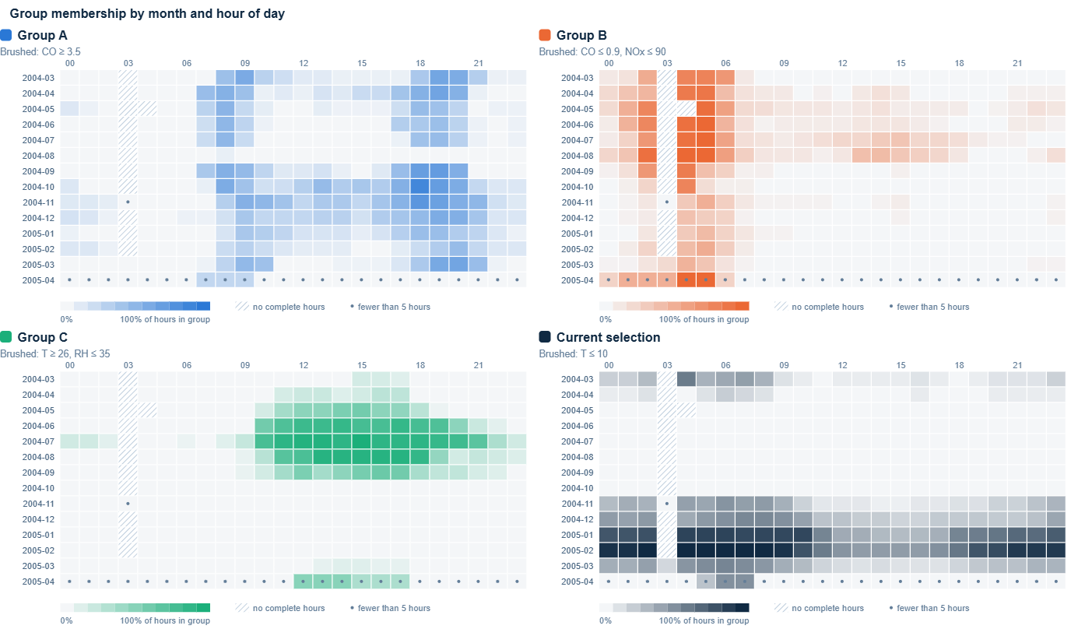
- Membership matrices (month × hour of day) for Groups A, B and C and the cold-hours selection (D).
- Group A: from March to July 2004 only the two rush-hour peaks belong to A, and in August 2004 it almost disappears (1 of 408 hours). From November to February midday hours join it (11:00–16:00 rises from 5% to 20%), as do late-night hours (00:00–02:00, from 1% to 8%), while the rush-hour peaks hardly change (43% in spring and summer, 42% in winter). By March 2005 the midday hours have left again (2%).
- Group B: its core is 04:00–05:00 in every month, but 99% of those hours belong to B in July–August against 40% in November–February. In July–August daytime hours also join (23% of 10:00–17:00, against 1% in winter).
- Group C: in April–May it covers midday only (38% of 12:00–16:00, almost nothing after 19:00). In June–August it widens to 77% of 10:00–21:00. It is absent from October to February and returns at midday in March–April 2005.
- Group D: it covers 71% of all hours in January–February, but in March–April 2004 only nights and mornings (21% of 00:00–08:00 against 3% of 12:00–17:00).

Changes in the Defining Attributes
The monthly profiles (Figs. 7–9) show that the combination of attributes that makes a group different also changes:
- Group A: from March to July it is mainly a CO, C6H6 and S1 group, with NOx only moderately raised (median 227–296 ppb). From September NOx becomes much more important (506–733 ppb), and NO2 and S5 also rise, with the highest NO2 median in February 2005 (221 µg/m³). In the monthly parallel coordinates (Fig. 10) A’s median dips at NOx in spring and summer but stays high in autumn and winter. In June and July, A also has lower RH than the monthly median.
- Group B: from March to September it is defined mainly by lower CO, C6H6 and S1, with NOx and NO2 only a little lower. In August 2004 the row is almost grey, as B’s medians are close to the monthly medians, which matches B spreading into the daytime. From November to February the strongest blue is on NOx, NO2 and S5, so winter clean hours are defined by low nitrogen oxides rather than CO.
- Group C: in March–April of both years it is strongly defined by high T and low RH, which marks rare warm, dry spells. In June–August these differences fade because all hours are warm, and in September higher NOx and NO2 (329 ppb and 145 µg/m³) join the profile.
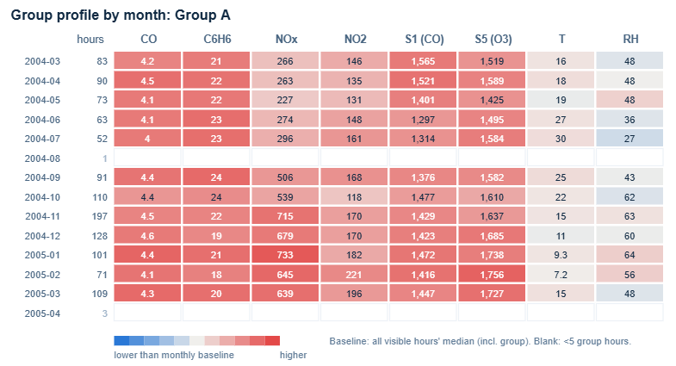
- Monthly profile of Group A.
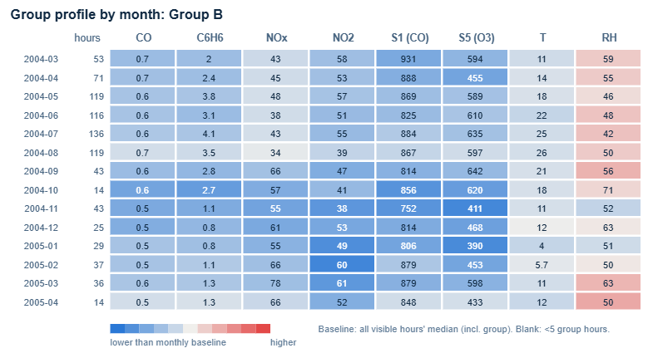
- Monthly profile of Group B.
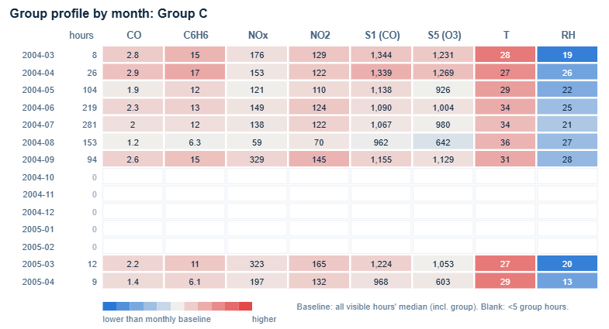
- Monthly profile of Group C.
For Group D, low T and high RH define the group in November and March–April 2004, but in January–February D covers most hours, so its medians are close to the monthly medians.
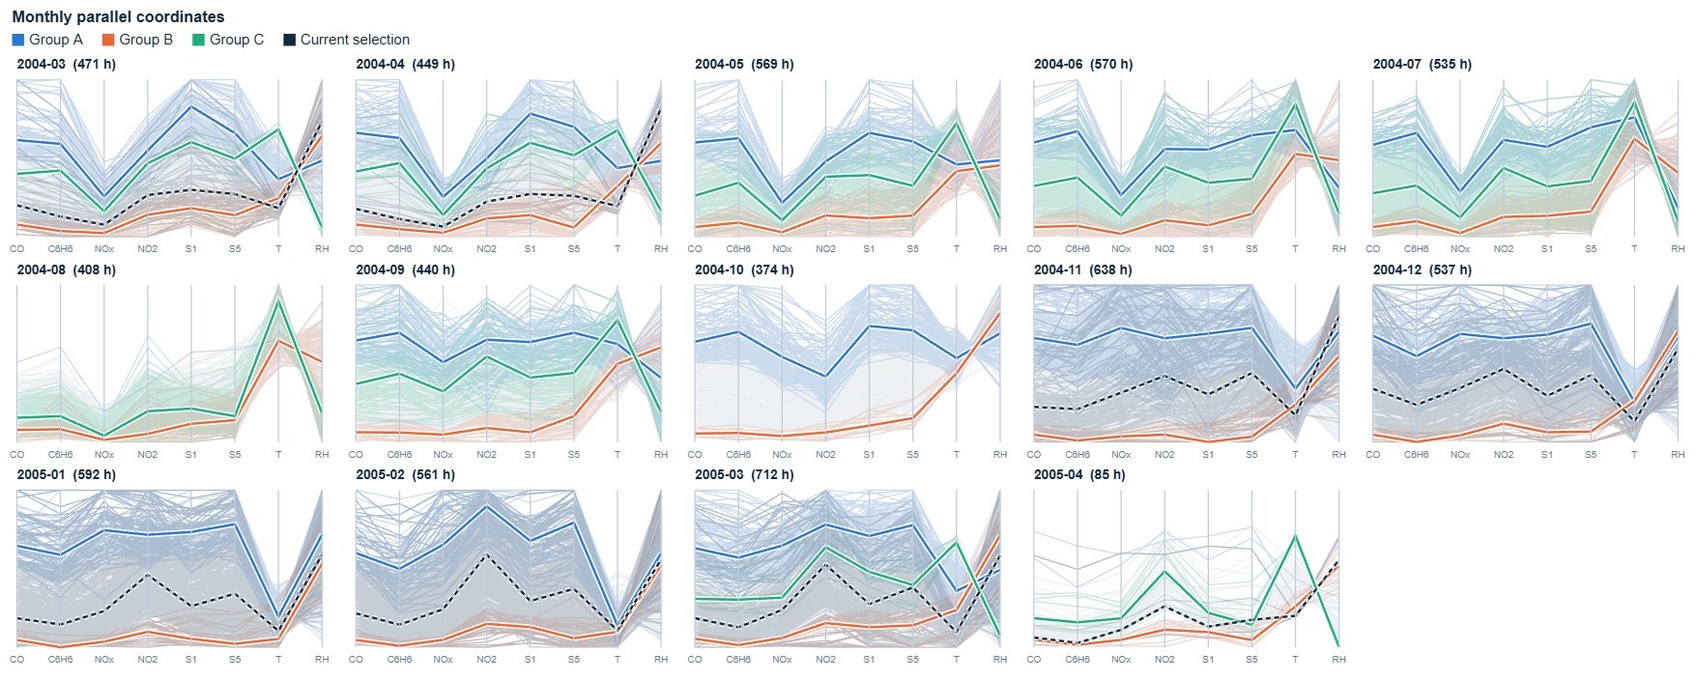
- Monthly parallel coordinates. Thick lines are group medians for each month; the dashed line is Group D.

Summary and Limitations
Both the membership and the defining combination change over the year. The biggest change is between summer and autumn 2004: in August Group A almost disappears and Group B spreads into the daytime, and from September Group A becomes NOx-led and takes in midday hours. Task 3 looks at this period. Some change on the sensor axes (S1, S5) may come from drift, and October 2004 and April 2005 (only 85 complete hours) are based on fewer hours.

Task 3

Identifying the Critical Moment
Task 2 showed that Group C (T ≥ 26 °C and RH ≤ 35%) disappears in autumn: the membership matrix (Fig. 6) has 94 Group C hours in September 2004 and none in October. To find when, we used interactive date–hour heatmaps of Group C membership, temperature and relative humidity for 25 September–10 October, 11:00–17:00 (Fig. 11). The panels share the same rows and columns, hovering a cell shows its values, and grey cells are hours with missing data.
The heatmaps show a clear break between 29 and 30 September. At 14:00–17:00, all four hours belong to Group C on 29 September and none on 30 September, and all eight hours are available. 29 September at 17:00 is the last Group C hour of 2004; the group only returns on 16 March 2005.
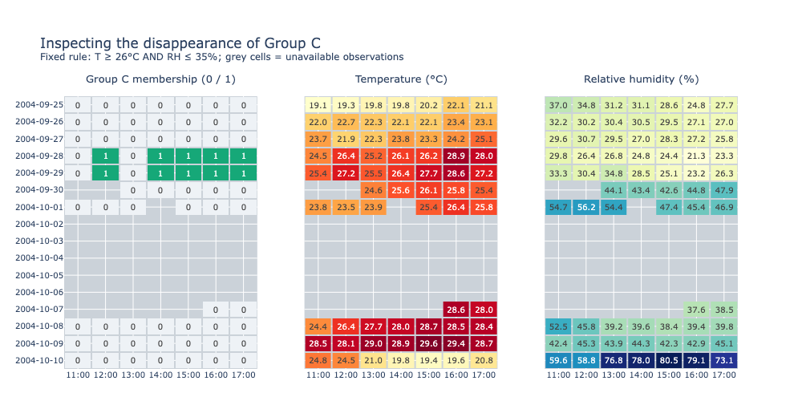
- Date–hour heatmaps of Group C membership, temperature and relative humidity, 25 September–10 October 2004, 11:00–17:00 (grey cells: missing hours).

What Changed
On 29 September the four hours have temperatures of 26.4–28.6 °C and relative humidity of 23.2–28.5%. On 30 September the humidity rises to 42.6–47.9% at every hour and the temperature falls below 26 °C at 14:00, 16:00 and 17:00 (26.1 °C at 15:00), so all four hours leave Group C.
The pollutants change much less: CO is 2.4, 2.8, 3.6 and 4.0 mg/m³ on 29 September and 2.2, 2.8, 3.9 and 6.5 mg/m³ on 30 September. The 16:00 and 17:00 hours are in Group A on both days, so they move from Groups A and C to Group A only, while 14:00 and 15:00 move from Group C to no group. The change is in the environmental part of the profile; the traffic pattern stays the same.

What-if Scenarios
We tested three alternatives for the 30 September hours using the previous day’s value at the same hour: temperature only, humidity only, and both. Everything else, including the pollutants and group rules, is unchanged. The scenario heatmap in the tool shows the result (Fig. 12):
- Restoring temperature only keeps 0/4 hours in Group C, because humidity stays above 35%.
- Restoring humidity only keeps 1/4 (15:00, where the temperature already meets the rule).
- Restoring both keeps 4/4.
So the membership loss would have been avoided only if both temperature and humidity had stayed at the previous day’s level. Because CO is unchanged, the 16:00 and 17:00 hours also stay in Group A, so all four hours keep exactly the same groups as on 29 September.
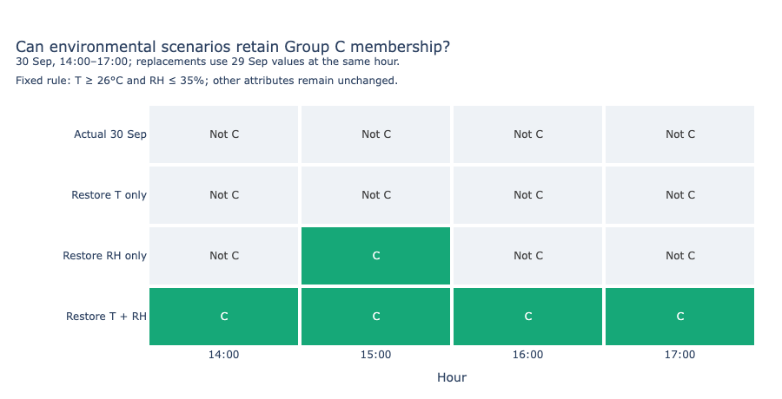
- What-if scenarios for 30 September 2004, 14:00–17:00, using the previous day’s temperature and/or humidity. Only the joint scenario keeps all four hours in Group C.

Limitations
Because Group C is defined by temperature and humidity, this result follows directly from the group rule and does not show that the weather changes the pollution. We also tried a model-based what-if for a Group A change at 17:00 on 20 September 2004 (Random Forest models with temperature, humidity and time of day). Adding temperature and humidity did not improve the models (test R² 0.404 against 0.418 for CO, and 0.145 against 0.280 for NOx), and the CO model predicted 2.63 mg/m³ against the observed 5.0 mg/m³, so we did not use it to claim that environmental changes would prevent entry into Group A. The details are in the Task 3 notebook.

Task 4

Evaluation Method
We conducted a task-based usability evaluation to assess how effectively the visual analytic tool supports Tasks 1–3. The evaluation involved two university students (S1 and S2) who were unfamiliar with the dashboard and represented different levels of experience with data visualisation: S1 was a novice user, while S2 had prior experience with basic exploratory visualisations.
Four tasks were evaluated: E1, discovering and saving groups using parallel coordinates; E2, interpreting monthly group membership and attribute profiles; E3, identifying critical changes in Group C using aligned heatmaps; and E4, interpreting predefined what-if scenarios.
For each task, we recorded whether participants completed it independently, required guidance, or only partially completed it. Their interaction bottlenecks, navigation patterns, and verbal feedback were systematically documented to identify usability barriers and inform interface redesign.

Evaluation Findings
The usability evaluation with the two participants revealed distinct operational difficulties and cognitive gaps across the four tasks.
In E1 (Group Discovery), S1 failed to recognize the brushing mechanism independently and required verbal guidance to begin selecting axes, whereas S2 completed the selection independently but spent considerable time searching for the relevant interactive controls. Both participants noted that the lack of prominent visual cues on the parallel coordinates plot hindered rapid feature discovery.
In E2 (Temporal Analysis), both participants completed the task only partially due to visual encoding ambiguity. S1 misconstrued the red cells as absolute indicators of dangerous pollution levels. S2 correctly understood the relative nature of the colour scale but expressed uncertainty about whether the monthly baseline included or excluded the active group members. These observations confirmed a significant lack of clarity surrounding the baseline definition.
In E3 (Critical Moment Analysis), S1 initially conflated missing data cells with non-member hours, needing direct clarification to proceed. S2 successfully located the critical period independently but paused to cross-check the legend to confirm what the grey cells represented. Both participants indicated that the multi-state encoding in the heatmap required more explicit labels.
In E4 (What-if Analysis), S1 only partially completed the task, misinterpreting the scenario results as predictive environmental forecasts rather than rule-based adjustments. S2 comprehended the resulting shift in group distributions but commented that the explanatory notes for the rule-based logic were too unobtrusive to be noticed without effort.
Overall, the evaluation established three high-priority areas for redesign: on-screen brushing guidance (E1), explicit clarification of the monthly baseline (E2), and distinct labelling for missing observations (E3). These informed the interface modifications detailed in Section C and Fig. 13.

C. Design Improvement
Three interface improvements were implemented to address the identified usability issues.
For E1, a visible instruction, “Drag along an axis to brush and filter hours,” was added near the parallel coordinates plot to help users discover the brushing interaction.
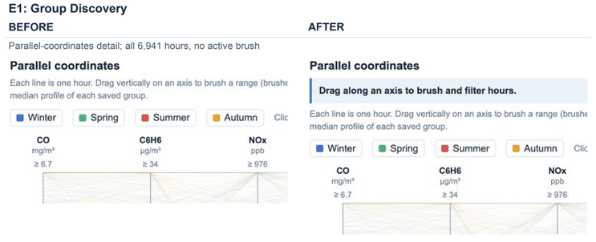
- Before-and-after comparison of the parallel coordinates interface, showing the addition of a highlighted brushing instruction to improve interaction discoverability.
For E2, the monthly attribute profile descriptions, colour legend and hover tooltip were revised to clarify that the comparison baseline represents the median of all visible hours in the corresponding month, including the selected group. Measurement units were also added to the tooltip.
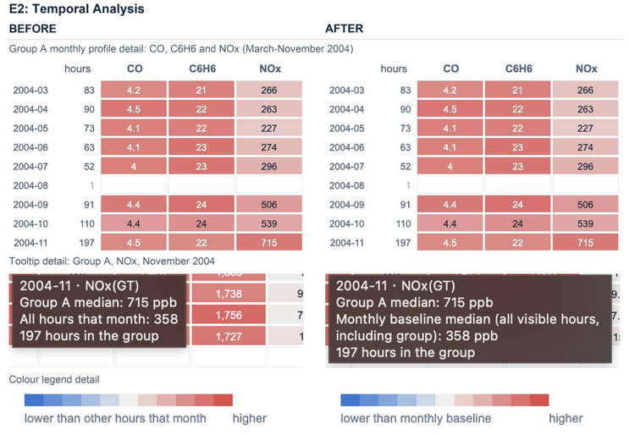
- Before-and-after comparison of the monthly attribute profile legend and tooltip, clarifying the monthly comparison baseline for Group A (NOx, November 2004).
For E3, the Task 3 heatmap legend was updated to distinguish missing observations (grey), non-member hours (pale) and Group C member hours (green). The notebook export template was also updated to preserve the legend when the visualisation is regenerated.
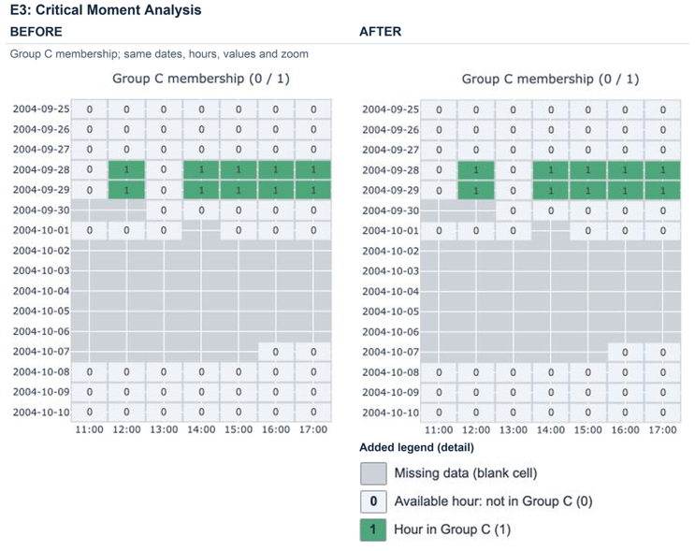
- Before-and-after comparison of the Group C membership heatmap, showing the addition of a legend distinguishing missing data, non-member hours and group-member hours.
These improvements clarify interaction guidance and visual encodings without changing the underlying data, calculations or analytical results.
Earlier design iterations also addressed visual clutter and interaction limitations. These included reducing line opacity, shuffling the drawing order, introducing percentile-based axes, improving group isolation through legend interactions, and fixing the group restoration function. The transition from Tableau to a web-based application also enabled more flexible linked interactions.

D. Verification and Retesting
A follow-up usability test was conducted with the two participants (S1 and S2) to evaluate the revised interface. Both participants independently completed E1 once the prominent brushing instruction was introduced, discovering and using the parallel coordinates filtering without requiring guidance.
For E2, both participants correctly interpreted the red–blue colour scale relative to the monthly baseline. S1 explicitly recognized that red cells denoted a group median above the baseline rather than an absolute pollution threshold, while S2 correctly understood from the updated tooltip and notes that the baseline encompassed all visible hours, including group members.
For E3, both participants successfully distinguished missing observations (grey), non-member hours (pale), and Group C member hours (green) using the revised three-state legend, verifying enhanced visual clarity.
Technical verification in the browser further confirmed that brushing, filtering, group saving, heatmap hovering, zooming, and resetting continued to function reliably. The underlying datasets, aggregations, and calculations remained completely unchanged..

References
- S. De Vito, “Air Quality,” UCI Machine Learning Repository, 2008, doi: 10.24432/C59K5F.
- S. De Vito, E. Massera, M. Piga, L. Martinotto, and G. Di Francia, “On field calibration of an electronic nose for benzene estimation in an urban pollution monitoring scenario,” Sensors and Actuators B: Chemical, vol. 129, no. 2, 2008.
- A. Inselberg, “The plane with parallel coordinates,” The Visual Computer, vol. 1, no. 2, pp. 69–91, 1985.
- B. Shneiderman, “The eyes have it: A task by data type taxonomy for information visualizations,” in Proc. IEEE Symp. Visual Languages, 1996, pp. 336–343.
- E. R. Tufte, The Visual Display of Quantitative Information. Cheshire, CT: Graphics Press, 1983.

